Student instructions: Joining a class blog on CampusPress:
Why join a class?
It is important that you join the class associated with your course, so your lecturer can easily access and moderate your site.

- Locate the site you have created for assessment, it is important you use this site for work associated with this module.
Ensure you select the site you will be using for your work.
The name in this list will be whatever you chose when you set up your site.
This can be changed at any time.
The URL will be studentnumberppdp for example 12325789ppdp, this can be checked by clicking on the site and checking the web address

- From the correct site go to ‘Dashboard’ go to ‘My Class’ and ‘Join a class’.

- Hover over ‘My Class’
- Click ‘Join a class’

- Ensure you join the class which is attached to your cohort. The name of your classblog will be provided by your lecturer.

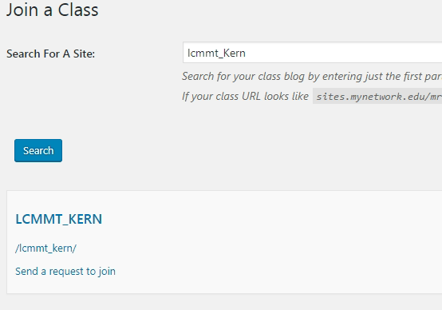
3. Search for the class blog associated with your cohort
5. Click
‘Send request to join’
4. Click ‘Search’

-----------------------------------------------END ---------------------------------------------------

