Version 2.2
April 2019

Module Evaluation
Staff Guidance

Timeline

Please note that the times given below are indicative only. Please refer to the Teaching Hub for current dates and deadlines: https://campuspress.uwl.ac.uk/teaching/how-to/module-evaluation/

Date | Action | Notes
Week 10 | Module Evaluation Survey (MES) opens | MES to be completed in-class; supporting materials accessible via the Teaching Hub*
Week 12 | MES closes | Access to results given to Heads of Schools, Heads of Subjects, Quality Leads and Senior Administrative Officers
Week 14 | Access to MES results given to Module Leaders by Heads of Schools | Module Leaders to share results with teaching team; guidance on how to access results (Tableau) is available on the Teaching Hub*
Week 15 | Deadline for Module Leaders to feedback to students  Copies of feedback given to students for each Module to be collected by Schools | Feedback to be posted on Blackboard
Week 16 | Deadline for Schools to return collection of all Module feedback given to students to PVC Student Experience | Format TBC
*Teaching Hub: https://www.uwl.ac.uk/teachinghub > How to > Module Evaluation

About the Survey
The MES uses the system EvaSys. For questions, please see Appendix 1. These questions are not to be personalised and no additional questions are permitted. Long-thin modules are surveyed at the same time as “normal” modules but a shorter Survey is used (see Appendix 2). Long-thin modules will be evaluated using the “normal” survey (see Appendix 1) at the end of semester 2.

Targets
The University has a target participation rate of 50% and a satisfaction rate of 86%.

Administering the MES
MESs are carried out at the end of the semester in class in week 10 (see timeline above). The MES will remain open for 3 weeks to enable students who were absent to complete the Survey. Any deviations from this timeline or exclusions must be agreed in advance with Sara Raybould, PVC Student Engagement.
The MES is to be completed in class, online, where possible using students’ mobile devices. A link to the MES will be provided on the Teaching Hub:
https://www.uwl.ac.uk/teachinghub > How to > Module Evaluation
Students will also have access to the survey from their student emails and the Blackboard homepage until the Survey closes.

What do I need to do in class?

    - Give students 5-10 minutes in class during Week 10 to complete the MES for your module
    - Introduce the survey to students. Both, a video and a PowerPoint slide have been produced for this purpose. You should first play the video (accessible via the Teaching Hub and Blackboard), and then display the PowerPoint with the link to the Survey (accessible via the Module Evaluation Sharepoint folder on the Teaching Hub).
    - Students complete the survey online on their laptop, smart phone or tablet.

Notes
• Students without access to the Internet in class can complete the survey online at any time during the 3-week period it is open.
• Students will have access to a survey for each module they are studying, you only need to give them time to complete your survey in your class.

Use and Access to Evaluation Data
Results will be made available to Heads of Schools, Heads of Subject, Quality Leads and Senior Administrative Officers. Heads of Schools will share the MES results with Module Leaders. Module Leaders should share the evaluation data with co-teachers on the module, including HPL colleagues. Please refer to the timeline above for further details.
Evaluation data is provided as a Tableau file. Guidance on this can be accessed via the Module Evaluation Sharepoint folder on the Teaching Hub.

Feedback
Please refer to the timeline on page 2 for information on when results will be available and when feedback should be provided to your students. Feedback must be given to students via Blackboard using the guidance in Appendix 3. Once feedback has been provided, this will be collated by your School and shared with the PVC Student Experience, Sara Raybould.

Appendix 1: Module Evaluation Survey. Questions 2018-19
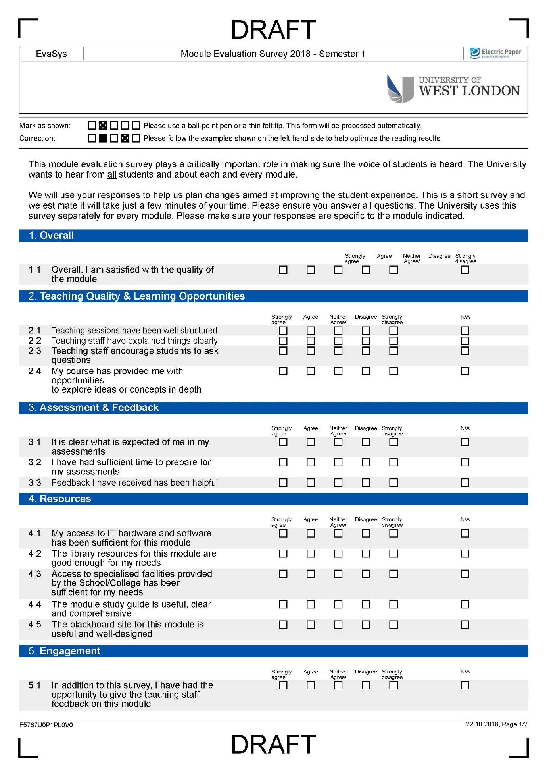
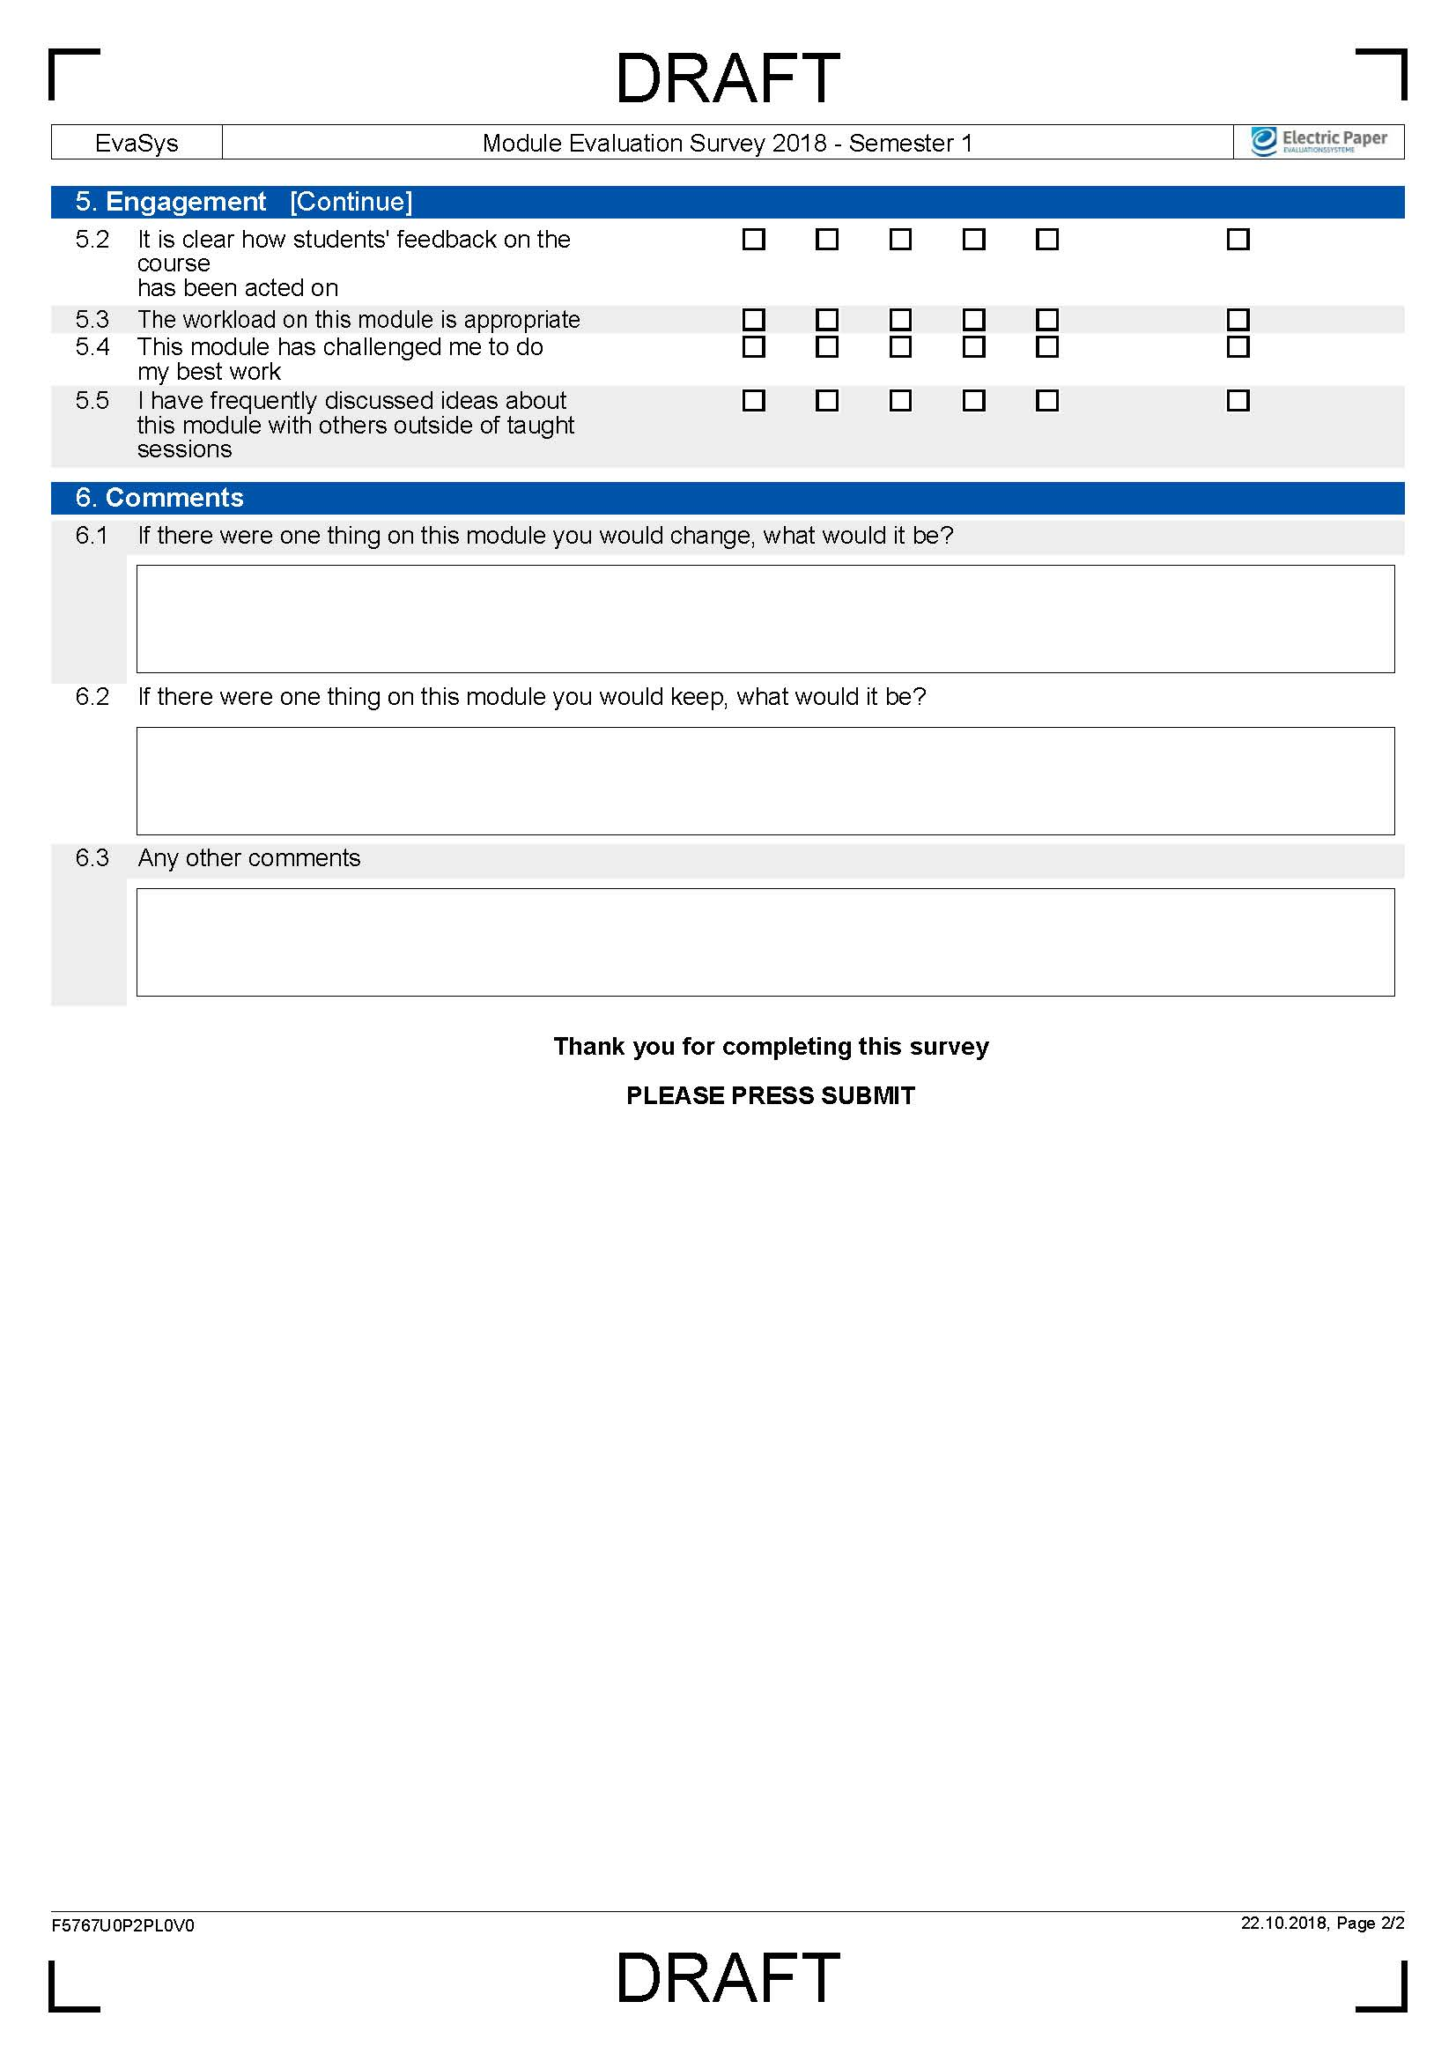

Appendix 2: Module Evaluation Survey, long-thin modules. Questions 2018-19

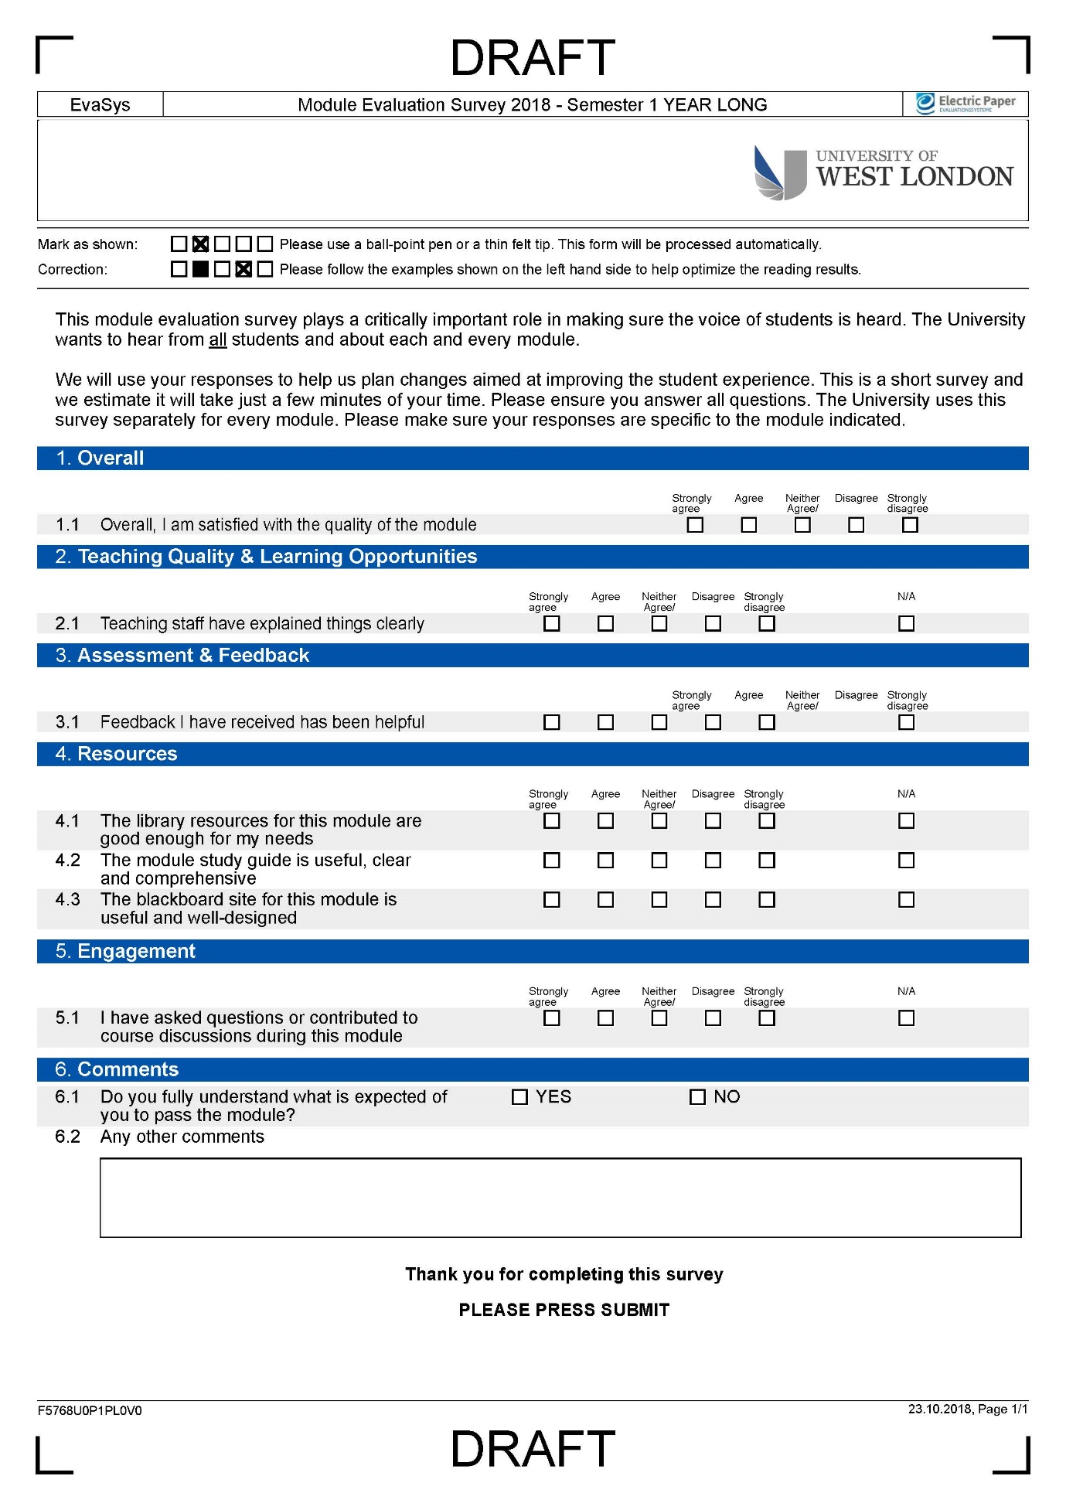

Appendix 3: Guidance to module leaders for the provision of initial feedback to students on Blackboard following module evaluation

The purpose of this document is to provide some suggestions for feedback to students following their responses to the module evaluation survey.
What follows is a suggestion only about how you might go about providing some initial feedback via Blackboard. Please feel free to frame your feedback in whatever way suits you, but we do request that whatever you say, you are as constructive and as specific as you can be and that your feedback is up on Blackboard by the deadline specified (see key dates above).
The feedback provided will be collated by Schools and shared with the PVC Student Experience.
Examples are provided below simply as suggestions as to how this might be done.

Suggested feedback

Content | Example
A brief comment to thank students for taking the time to complete the survey and the purpose of providing some initial feedback at this stage. | “Thank you for your responses to the evaluation of this module. This message is to let you know that I have read every response, which will now go on to inform the annual course report and planning for the future. One or two things raised can be addressed immediately and I will take these forward straight away.”
A few sentences giving a flavour of the overall feedback provided and some specific indication of what you are planning to do with it. Try to frame things in positive language and avoid being defensive. Better to say nothing at all about potentially sensitive aspects at this stage than to say something that might aggravate the situation. If sensitive issues are indicated in your data, these will be best addressed only after careful reflection and discussion with colleagues. | “Overall, you indicated that the module has gone well. Several of you particularly liked the way the sessions were structured and the feedback you have received so far. Of course, you will receive more feedback once your final assignment has been marked. There was some concern expressed about the timetable and the information in the module study guide. In relation to the module study guide, your feedback suggests that the description of the assessment may have caused some confusion. I will look into amending the way this is explained to make it clearer for the next cohort of students. In the meantime, I will add some additional guidance on Blackboard. I will also raise the timetable issue with my colleagues on the course team. I suggest that course reps take this to the course committee meeting, as this may be a wider issue.”
A closing remark about what happens next. | “Thanks again for your responses. Further feedback will be provided through course committees and school boards. Your course reps can ensure any ongoing issues are followed up in those contexts. At the end of the year I will produce a module report which will include detail as to what actions have been taken in light of your responses to this evaluation.”

