

**Creating UWL Replay (Panopto) Assignment folder**

**Why create an Assignment Folder in Panopto?**

An assignment folder gives the students a repository for their video. It not restricted by space and allows the student to upload a video from their device.

1. Click on the UWL Replay logo on your Blackboard homepage

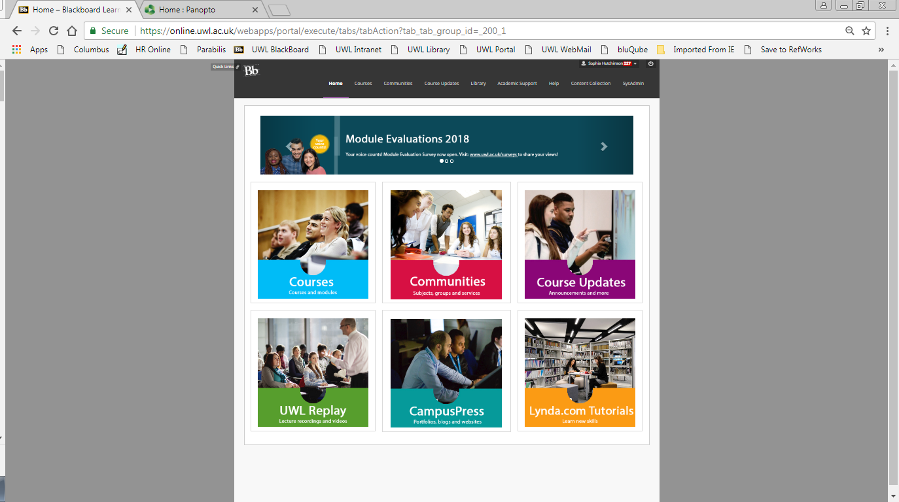

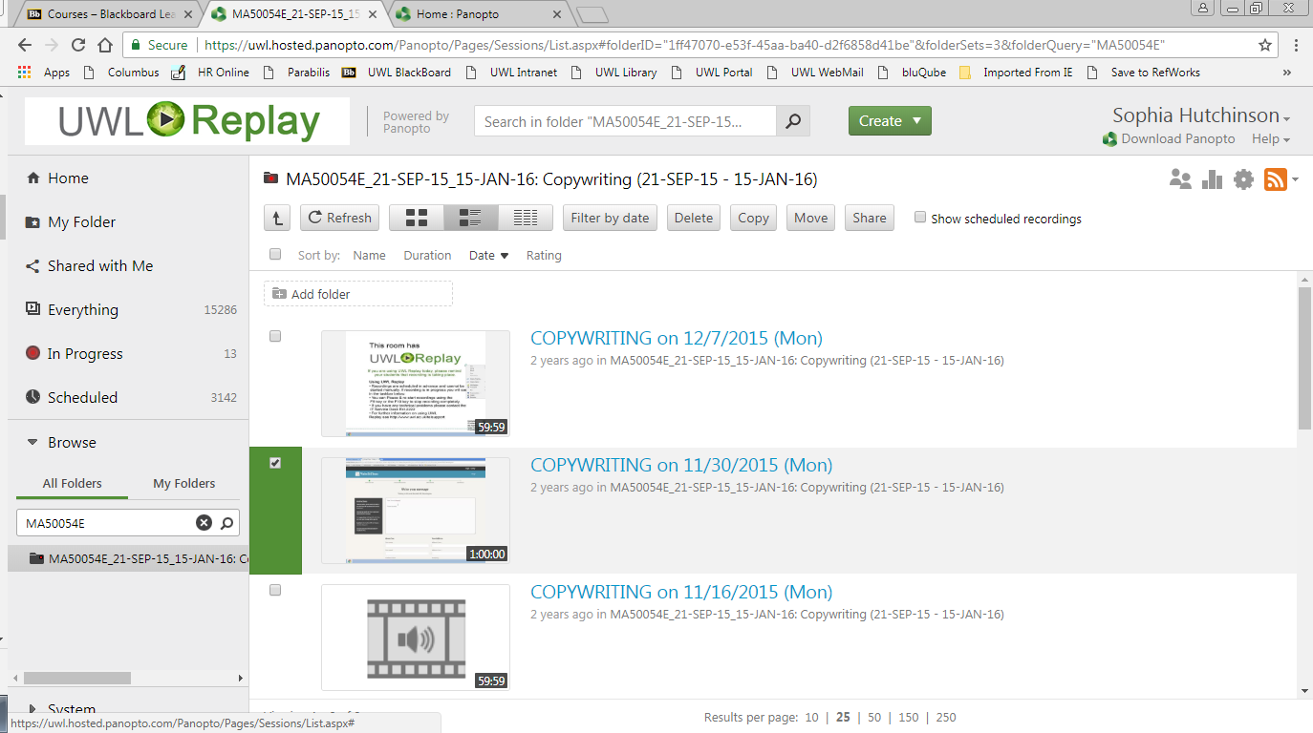

2. Select ‘My folders’ to filter, and search by module code (If your module is not appearing see *Part 2 of these instructions*)

4. Go to folder settings

3. Select the module folder once found

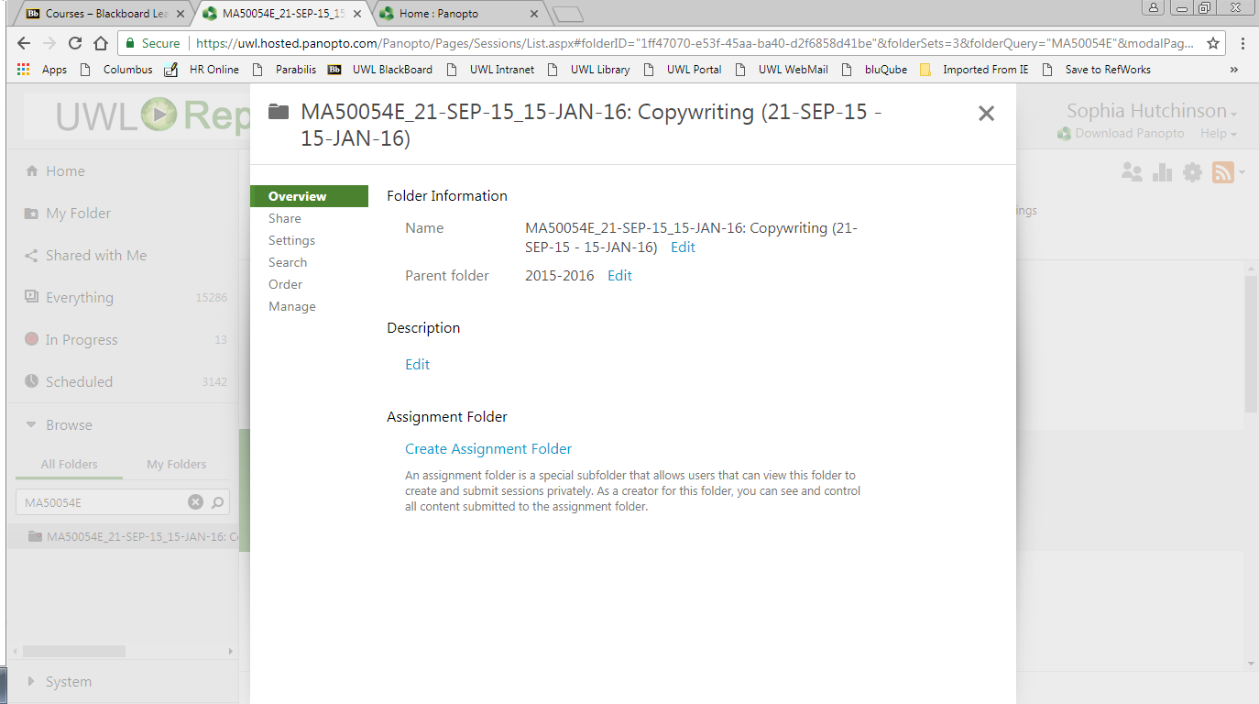

5. Within folder settings click ‘Create Assignment Folder’

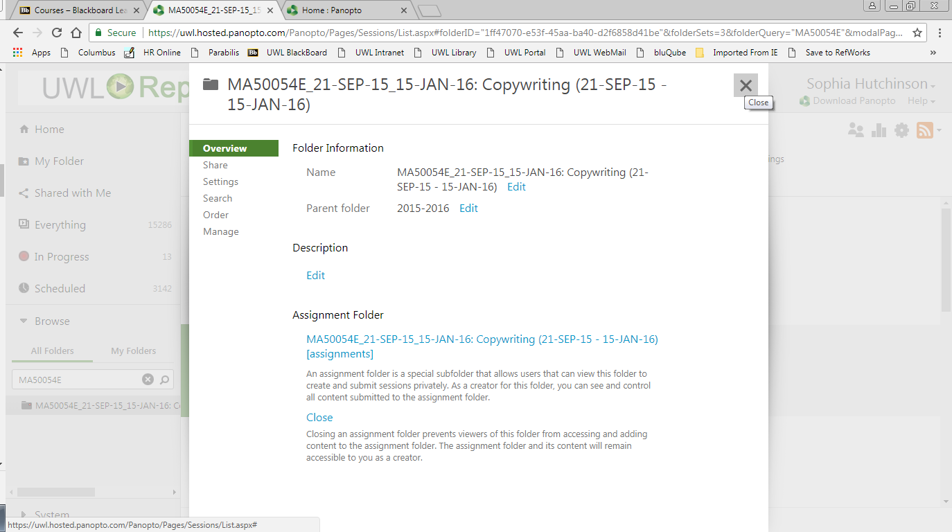

7. Once you see the folder has been created close the box.

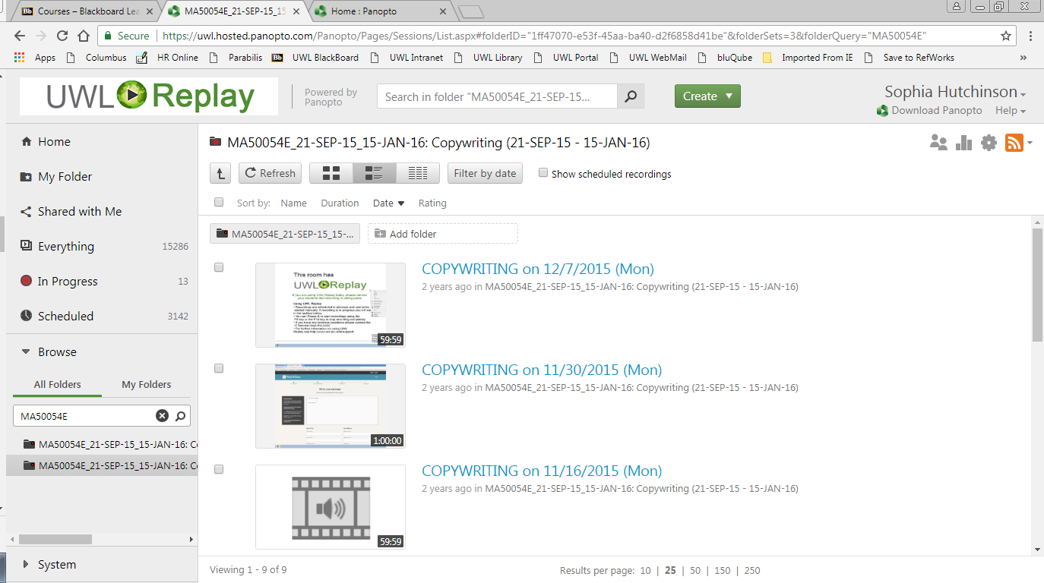

8. Click on the newly created assignment folder

9. Share this link with your students, it is recommended that you set up a web link on Blackboard for this.

They will be able to upload their video/audio files here as long as they are logged into blackboard

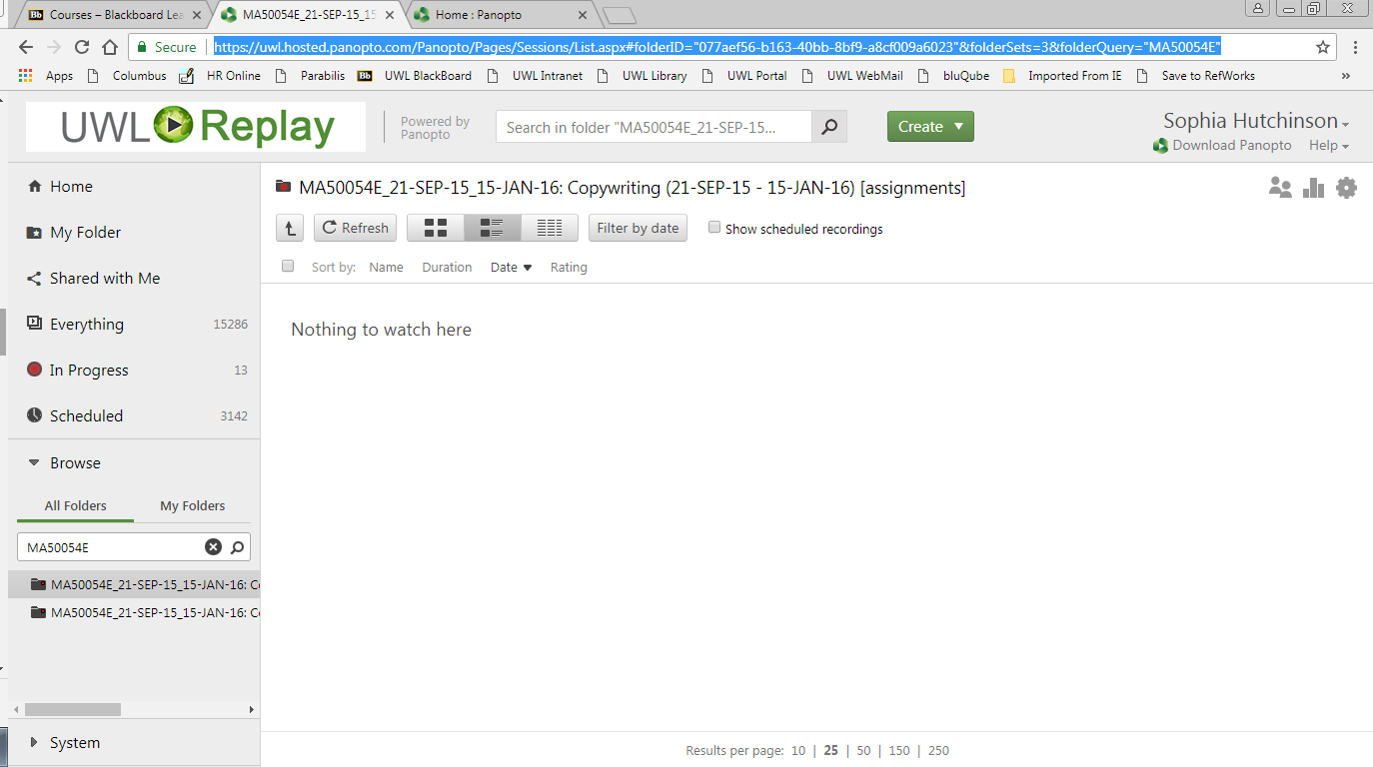

**Part 2 (Only necessary if you cannot find your module within UWL Replay)**

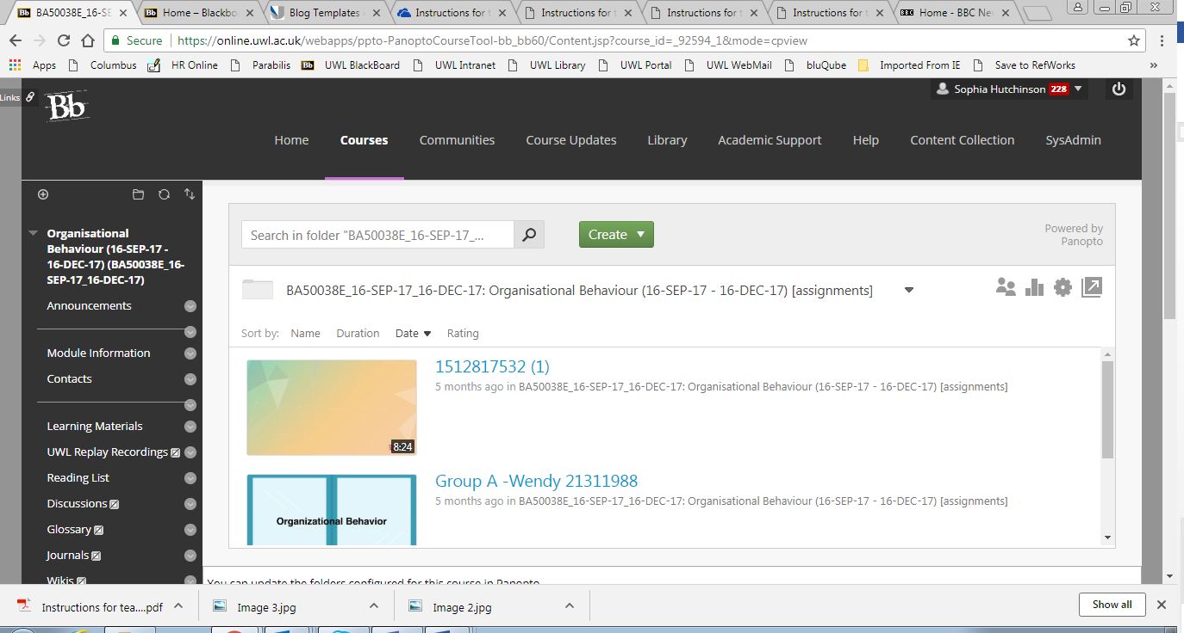

1. Click on the ‘UWL Replay Recordings’ menu item

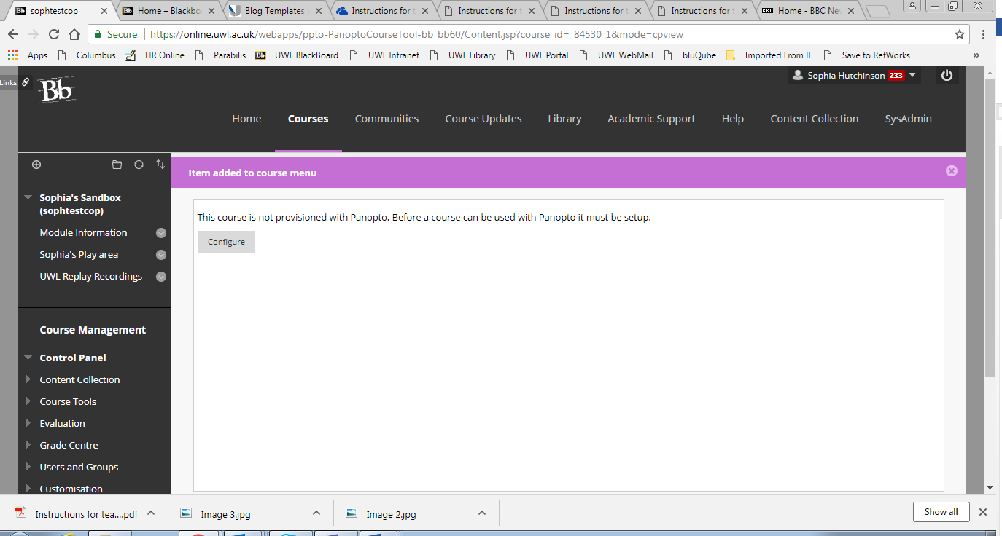

2. Click Configure

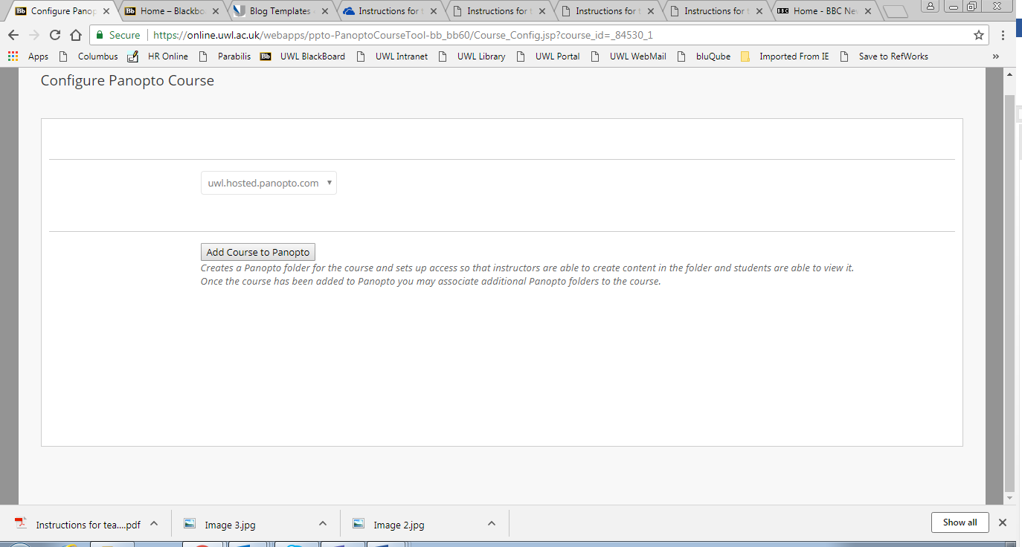

3. Click ‘Add Course to Panopto’

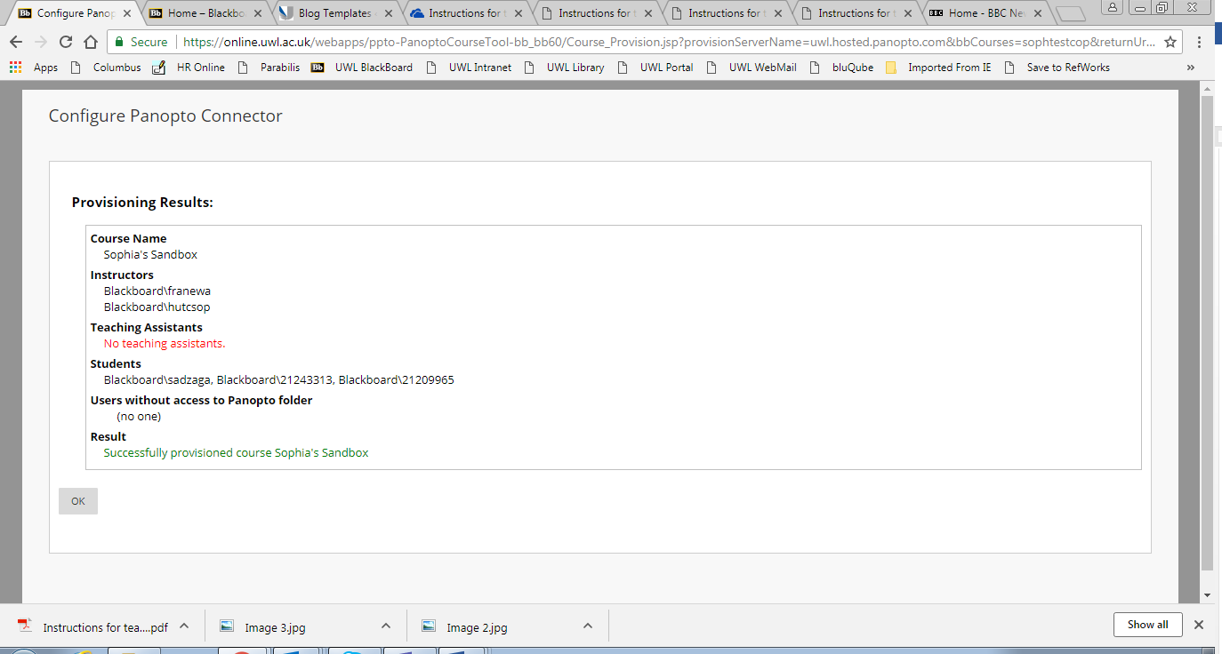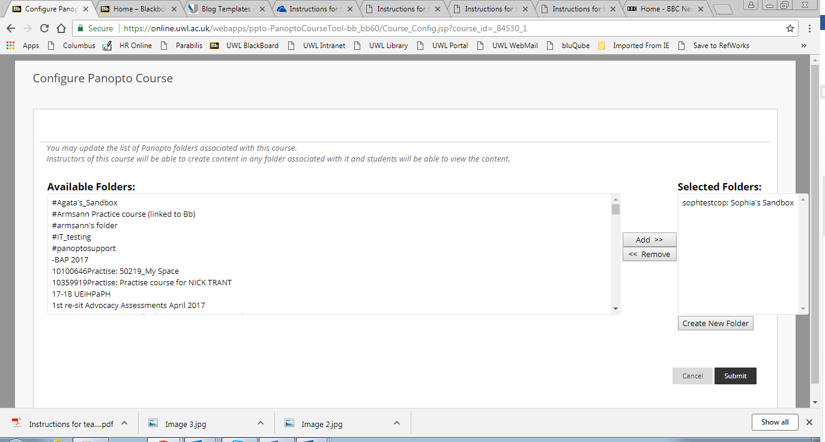

5. Click ‘Submit’

4. Click ‘OK’