Self-Enrolling to the Civitas Inspire for Advisors
Online Training module

1. Login to Blackboard and paste the following link into the URL address bar: https://online.uwl.ac.uk/ultra/courses/_103422_1/cl/outline and click ‘Enrol’.

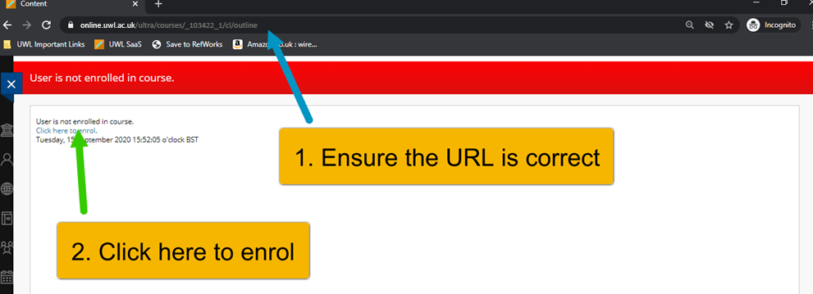

2. Click ‘Submit’ at the bottom right of the page.
3. You will be able to access the module from the module area of the homepage, tip: type to search for the site

