Grading Blackboard Assignments
Go to the module that contains the Blackboard assignment. Go to Course Management> Grade Centre> Full Grade Centre.

Find the column containing your Blackboard assignment.
Click on the grey arrow, and select group attempt, any assignments that need making will have
The top attempt is the most recent submission

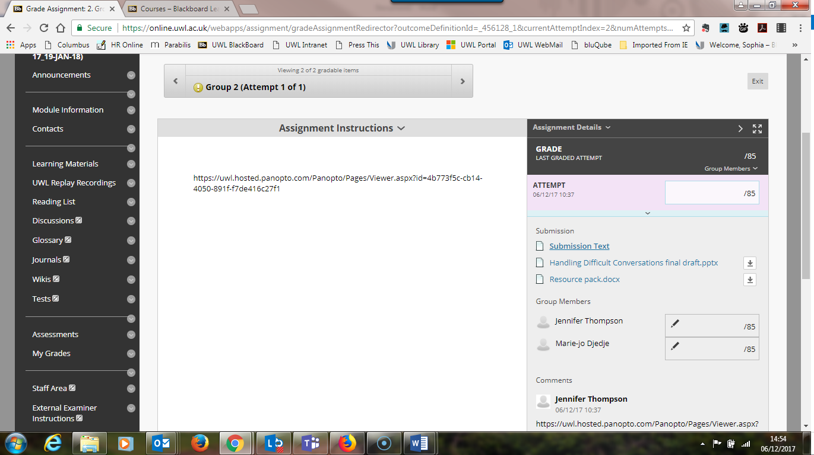
Click arrow to enter feedback. (Remember to click after submit after you finish).
Copy this link for the group video into another tab to watch
Enter grade here
Access any documents upload here

