Setting up a folder
Why Set up a folder?
We recommend settting up a folder for the video assessment componants and putting a description of what the students are expected to do to fully submit their video/audio files. This helps with the organisation of your course and gives better direction to students.

Complete the details of the folder as shown, and click submit. The description text reads as “You must﻿ ﻿complete all steps within this folder to successfully submit your video. Failure to do so will result in a non-submission.﻿﻿﻿﻿﻿﻿﻿”
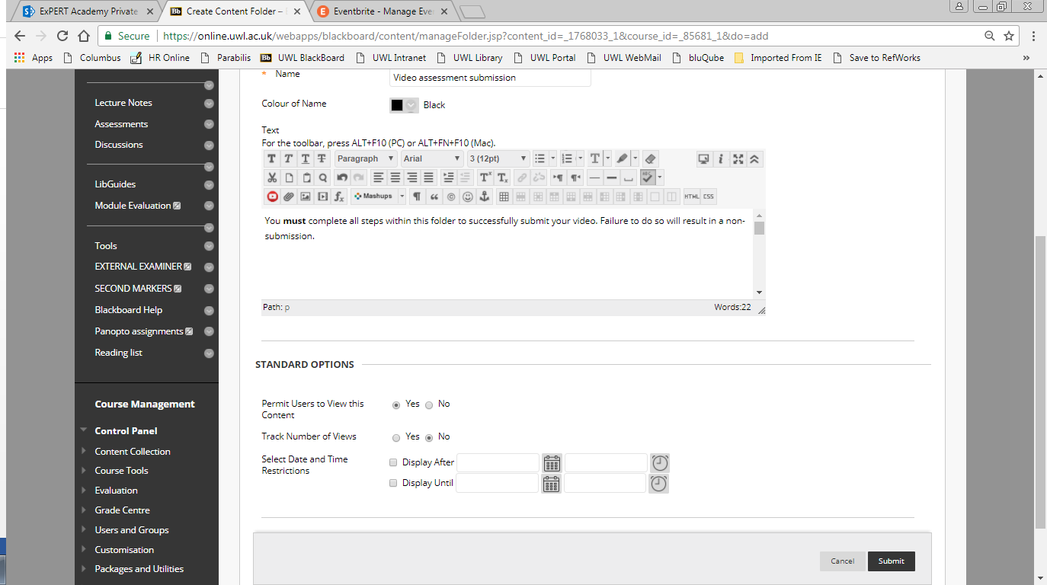
Insert Description/Explanation of folder.

