Creating a web link
Why create a web link in Blackboard?
By a creating a web link for your UWL Replay (Panopto) assignment folder you are giving the student direct access to the repository. This reduces the steps for students and lessens the chance of them submitting to the wrong folder. It is important that the student submits to the [assignment] folder as this gives the lecturer access and does not permit the other students viewing the media.
Copy the link from the UWL Replay (Panopto) assignment folder you made earlier (Step 1)

1. Copy the link from the assignment folder you have just created within Panopto
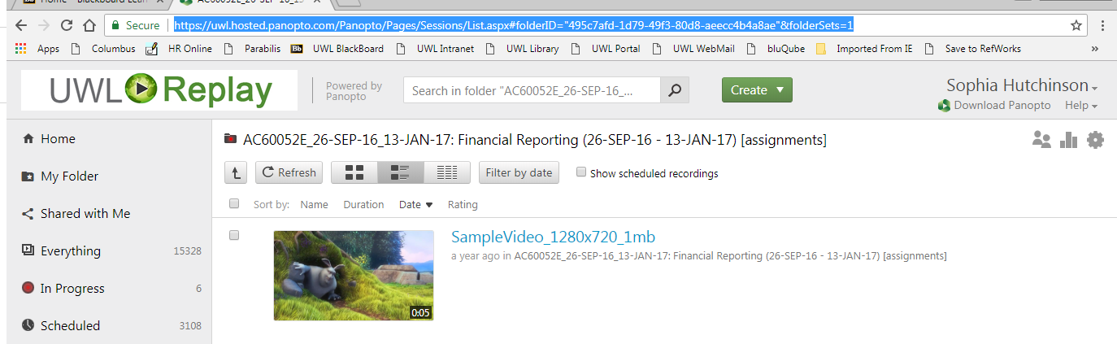
Tip: Make sure the folder URL you are copying has the module details followed by [assignments]
1.Click into the [assignments] folder

2. Insert the link into Blackboard as a ‘Blackboard web link’. This should sit within the top level folder you’ve created (step 2)

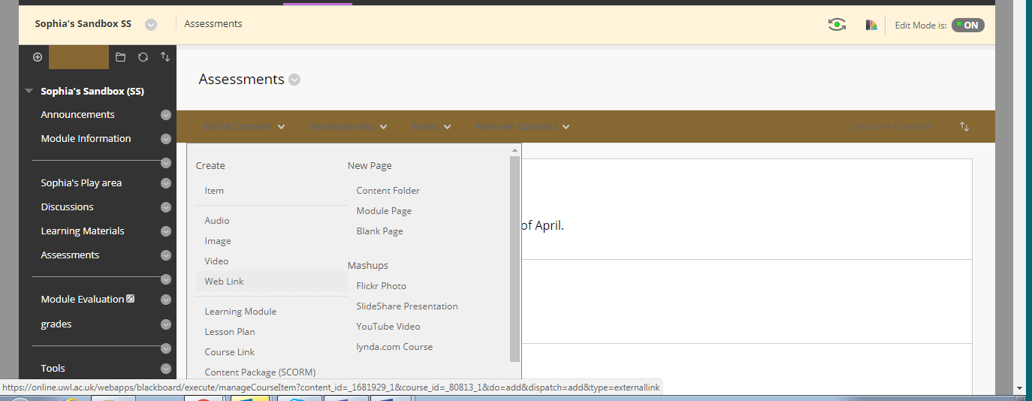

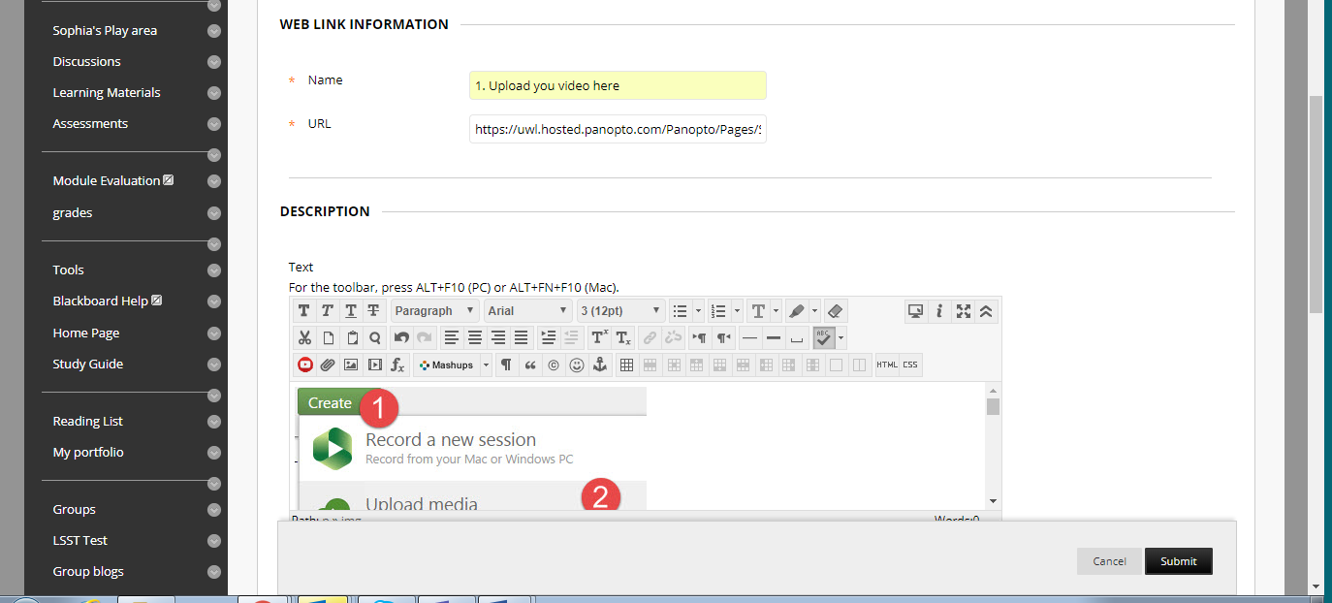
3. Recommended: Add ‘image 1’ provided in the appendix of the video assessment page on the teaching hub as well as any other relevant instructions to the description.
4. Click Submit
1. The recommended name is ‘1. Upload your Video here.’
2. Paste the URL for the UWL Replay (Panopto) Folder here.

