Self-Enrolling on Ultra base navigation

1. Login to blackboard and paste the following link into the URL address bar: https://online.uwl.ac.uk/ultra/organizations/_48136_1/cl/outline and click ‘Enrol’.
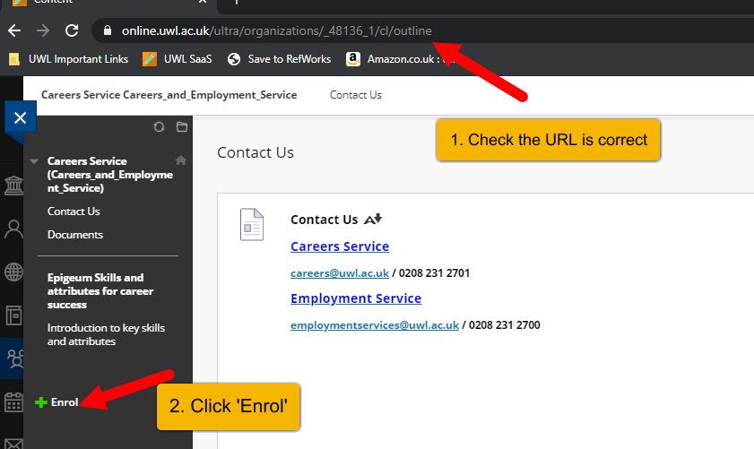

2. Click ‘Submit’
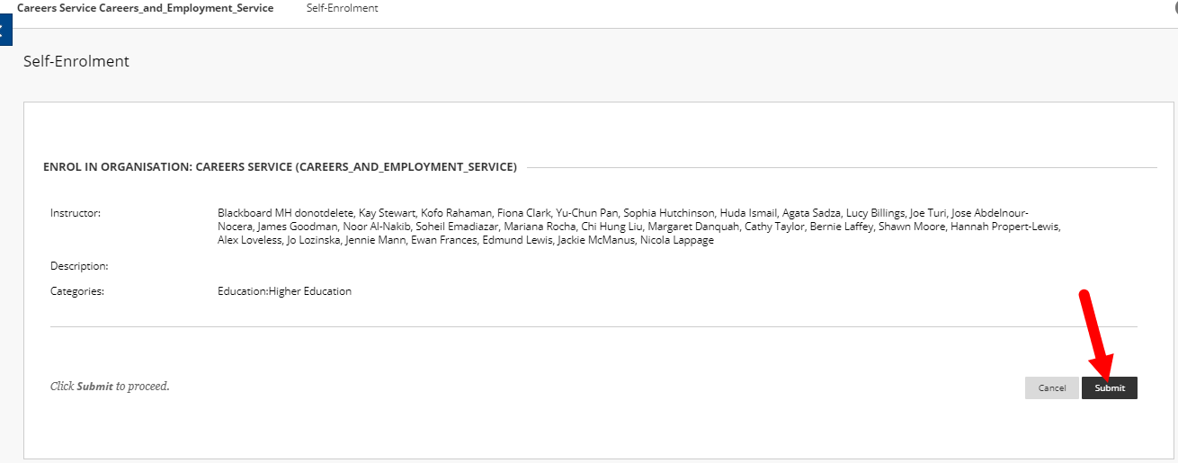

3. You will be able to search for and access the community from the ‘Communities’ area of the homepage:
