Table 1: Possible Activities to Engage Students in Concept Application and Problem Solving
Interactive Learning and Teaching Activities/Tasks (Individual and Group-based)
Think-Pair-Share | This is a simple cooperative activity. You pose a question or a problem. The students spend a minute or two on their own thinking about the answer and then pair up to share their solutions or answers for a further few minutes. If pairs aren’t easy to form, you can use a combination of pairs and threes. You then ask a few students to share their thoughts with the whole class.
Brainstorming | You ask a group (small or large) to thinks spontaneously of ideas in response to a catalyst topic, question or problem. The contributions are given and you (or a nominated ‘scribe’) record them quickly e.g. on a whiteboard or blank PowerPoint slide, without selection, criticism or organising/categorising of the ideas in the first instance. Later, ideas can be collated and analysed. This process can help break down and explore new and challenging concepts.
Snowballing | Begin by giving individual students a few moments to consider a question or problem alone; you can encourage them to jot down a few thoughts on paper. Then ask your students to work in pairs for a few minutes, to share their findings or ideas with their partner. The next step is to move from pairs to fours, fours to eights and so on (depending on the size of the group and the time available), until the whole group is re-convened into a plenary situation.
Peer Tutoring | Students help or teach each other. It allows the faster learners to teach the slower ones, who have thus the chance to query misconceptions without embarrassment. Peer tutoring helps the peer tutor to reinforce their learning.
Demonstration | You show how something is done. Requires complete concentration on the demonstration with clear and detailed commentary. Should be followed by students’ practice of the skill being demonstrated and other learning activities such as a written description. Similarly students can be asked to demonstrate a skill or activity that they have practised or acquired to the rest of the group.
Student Presentation | Individual or groups of students deliver a short, prepared presentation to the whole class, on a topic selected by you or the student/group.
Role-Play | Students ‘take on’ or enact a specified role in a simulated scenario, e.g. key protagonists in a court of law, professional colleagues on a hospital ward, national security teams in a diplomatic crisis situation, or as ‘lecturers’, ‘students’ and ‘peer-observers’ in microteaching. The point is to expose students to (practising) situations relevant to their studies/subject.
Simulation Game | Students complete an activity within a framework of rules towards a given objective. It can support understanding of concepts and acquisition of knowledge within a creative learning context. Simulation games are characterised by some of these features: rules, moves, turn-taking, winners and losers, success and failure.
Experimental design protocol | Students are given a brief research-related scenario and asked to formulate a hypothesis and an experimental design to test it with.
Data Interpretation Task | You give students a short case study, a graph from a research paper, a table with rough or transformed data, and ask them to propose a method and analyse the data or to interpret the portrayed results or to reverse engineer the experimental design behind them.
Jigsaw | Setting up groups in your class where e.g. Group A can have X information and Groups B & C can have Y and Z information. In Stage 1 of the Jigsaw, each group reviews, discusses and evaluates its own information (X, Y or Z, respectively). In Stage 2 new groups form that include representatives from Groups A, B and C. The new groups explore and evaluate solutions, make decisions, or negotiate views based on the combined information (X+Y+Z).
Case studies | You provide a description of a situation, often from real life, that students use as the basis for discussion.
Sentence-Completion | Useful for getting discussions started on pre-session reading preparing for e.g. a seminar or tutorial. It can also be used to make connections between a lecture and its associated seminar. Step 1 involves completing individually one or more sentences (e.g. The idea I most take issue with in the text/from the lecture is…); Step 2: students read their responses to the questions in turn, in groups of e.g. 4-5, and agree which ones they’d be most interested to discuss/explore further with the whole class/tutor; Step 3: Facilitate discussions on the selected questions in the whole class.
Debate | You provide a proposition (or motion) in the form of a contested statement (for example, “Proportional Representation leads to weak government”). Students choose (or are asked) to support or refute the proposition, and a chairperson is nominated. Seating arrangements often involve a split between factions, and individuals from the ‘pro’ faction can be asked to propose and second the motion, while the opponents offer counter-arguments. Debate gives opportunity for different points of view to be expressed and can be very engaging, leading to a formal vote.
Melees, delegate discussions and market groups | Activities where ‘ambassadors’ from different groups share ideas, knowledge or conclusions from group work with the rest of the class. Melees are where everyone in the class is free to work with or consult anyone else. Market place is where the class is divided into ‘stall holders’ who hold information and ‘researchers’ who are seeking information. Delegate discussions are where the class is divided into groups each charged with a problem or task to complete. Once completed, groups are rearranged so that a delegate from each group comes together with one delegate from each of the other groups to share ideas.
Buzz groups | Holding discussion of a particular carefully considered idea in small groups for a few (2 – 15) minutes. Reporting back may not be required. Can be used at the start of the session to establish existing knowledge from the previous session, to check learning through the session, and to formulate questions to ask you in the follow up session.
Fishbowl | Useful for generating and examining divergent views, and for cross-cultural or intergroup understanding. Can offer a safe way to learn and get feedback on group behaviour. Place your students in two rings – outer and inner. The inner group discusses an issue or topic while the outer group looks for themes, patterns and soundness of argument; perhaps using a checklist. The outer group gives feedback to the inner group. An empty chair in the inner group can be included to allow someone from the outer group to move to the inner group to ask a question or make a comment.
Research project | Students identify an aspect of their subject / content of module / lecture, etc. to research, usually culminating in a written paper or a presentation.

Examples of research-inspired activities in the disciplines
Enhancing first-year undergraduate expertise and skills through group research | History undergraduates engage in a Making History group project.  Student research groups produce e.g. videos designed to address their core research question laterally, in addition to a more conventional essay work.
Research-based education for first undergraduates | Physics undergraduates get involved in a ‘connected curriculum’ type project work. One such project, ‘All Optical Material Characterisation’, requires materials to be blasted with a laser and then analysed to determine composition. First Years act as volunteer researchers to develop the chamber to be used for the works and to source the materials. Postdocs and PhD students train them in the role and Teaching Fellows in the labs act as facilitators to ensure that the First Years are appropriately supported. Fourth-year researchers then undertake the major data analysis / collaboration and develop the system further.
First year undergraduates as researchers | The first-year core Fundamentals of Biology module originally finished with a standard written exam. Now instead of a test, students are challenged to design, conduct and present their own lab research projects. These take place over 2 weeks – one week in the lab and the second spent drafting a paper. The model organisms available in the lab are fruit flies and fission yeast – both familiar to the students and possible to generate empirical data on in just a couple of days. An initial session to introduce ideas, e.g. looking at aging-related traits in fission yeast and the significance of eye colour in flies, sets the projects up. The first two days are spent manipulating the organisms. Everyone has a go at the different techniques before forming groups which define their projects.
‘Mystery specimen’ project | Biology students on a Vertebrate Life and Evolution are given a different part of an animal and tasked with identifying it. They then write a journal article about the experience.
Scenario-based learning | Electronic and Electrical Engineering undergraduates are tasked to conduct group projects based on particular engineering scenarios, such as ‘Electromagnetic lifting’ (Redesign an electromagnet to maximise the lifting force using only a single battery) and ‘Java based image coding for airport security’ (Develop a piece of software in Java to scramble and descramble passenger images using a secret key).
Collaborative (extra-curricular) research for undergraduates | Astrophysics students participate in observations of transit events of extra-solar planets. The students share ownership in the research process, the results, and the published work. They interact between the year groups involved in the project, and have created their own research group – Exocafe.

Table 2: Class Assessment Techniques (CATs) to adapt for online reviewing of learning
Interactive Learning and Teaching Activities/Tasks (Individual and Group-based)
Directed paraphrasing | Ask students to write a layman’s “translation” of a concept you’ve just taught – geared to a specific individual or audience. Allows for assessing comprehension and transfer of concepts.
One-Minute paper / Muddiest Point | During the last few minutes of the class period, ask students to answer on a half–sheet of paper: “What is the most important point you learned today?” and, “What point remains least clear to you?” The purpose is to elicit data about students’ comprehension of a particular class session.
Chain Notes | An envelope with a question about the class content is passed around to students, each of whom writes a short answer, puts it in the envelope, and passes it on. Allows collection of anonymous feedback on content (learning).
Application article (*cards) | In the last 15 min of class, students are asked to write a short news article about how a major point relates to a real-world situation (alternatively, write about how the point relates to the wider subject). Allows creativity, lateral thinking, and can be done individually or in pairs / groups. *A modification of this are the Application Cards: After introducing a fundamental concept to students, ask them to write down at least one real-life application of it. Allows determining how well they transfer knowledge.
Student generated questions* | Class is divided in to groups, each of which is assigned a topic they have to write a question and answer on for e.g. a test in the next session. Thus each student can be sure to get at least one question right on the test. Allows for critical review of knowledge by the students. *Can be used for writing test questions and model answers for specified exam topics.
Notes check | Give students a few minutes to compare notes in pairs, summarise the most important information, and identify sticking points to raise for you to clarify. Allows reflection on learning in class and immediate filling the gaps / correction.
Memory matrix | Students fill in cells of a two–dimensional diagram for which you have provided labels.  Allows testing of knowledge retrieval and recognition.
Background knowledge probe | Short, simple questionnaires prepared by you, for use at the beginning of a course or at the start of new units or topics. Can serve as a pre- (or preparation for a) test. Allows for establishing base level of knowledge and understanding in the subject and how (much) students vary.
Pro-Con / categorising grid | Students a) write quick lists of pros/cons, costs/benefits, advantages/disadvantages of an issue, question or value of competing claims; or b) complete a grid of 2-3 overarching concepts and a variety of subordinate elements associated with the larger concepts. Examines students’ objectivity and analytic skills.
Content, form and function outline | In an outline form, students analyse the “what” (content), “how” (form), and “why” (function) of a text (e.g. poem, newspaper story, billboard, critical essay) or a research paper. They then write brief notes answering the "what, how, and why" questions in an outline format that can be quickly read and assessed. The method is also called “What, How, & Why Outlines. Enables the assessment of critical thinking.
What’s the principle | Present students with a problem and once they identify its type, ask them to decide what principle(s) they should apply for its solution. Focuses on the second step of problem solving.
Process analysis | Ask students to keep a record of the steps they take in solving a problem/conducting a task, and at the end – analyse their approach to arriving at the solution/conducting the task. Allows identifying problems with application.
One-sentence summary | Students answer the question “Who does what to whom, when, where, how, and why?” (WDWWWWHW) on a given topic, and create an informative, grammatical, long-summary sentence. Allowed assessment of skills in synthesis and creative thinking.
Approximate analogy | Students complete the 2nd half of an analogy— “A is to B as X is to Y”. The analogy is described as approximate because rigor of formal logic is not required. Allows to test synthesis skills and creative thinking.
Documented problem solutions | Students track in writing the steps they take to solve particular problems in a ‘show & tell’ format. Allows testing of problem-solving skills.
Problem recognition task | Students are given scenarios / case studies / examples of particular “problems” (that relate to concepts you teach), and are asked to identify the type of problem / the concept it relates to. Allows testing problem solving and conceptual understanding.
Paper / Project prospectus | Students are asked to create a brief plan for a paper of a project based on your specific requirements. Allows testing application / performance skills.
Data interpretation task | Students are given a short case study, a graph from a research paper, a table with rough or transformed data, and are asked to propose a) an underlying hypothesis; b) a method of analysis; c) an approach to problem solving; d) the principle / concept, etc. exemplified, and so on. Allows testing analytical and problem solving skills.

Asking Appropriate Questions in CATs
Examples of appropriate questions you can ask in the CAT format:
- How familiar are students with important names, events, and places in history that they will need to know as background in order to understand the lectures and readings (e.g. in anthropology, literature, political science)?
- How are students applying knowledge and skills learned in this class to their own lives (e.g. psychology, sociology)?
- To what extent are students aware of the steps they go through in solving problems and how well can they explain their problem-solving steps (e.g. mathematics, physics, chemistry, engineering)?
- How and how well are students using a learning approach that is new to them (e.g., cooperative groups) to master the concepts and principles in this course?

Method for Reviewing / Activating (Prior) Knowledge (1): Concept Inventory
Begin with a clear understanding of the knowledge and skills that you want your students to acquire. The questions should probe a student's comprehension or application of a concept rather than factual recall.
Concept test questions often describe a problem, event, or situation. Examples of appropriate types of questions include:
- Asking students to predict the outcome of an event (e.g., What would happen in this experiment? How would changing one variable affect others?)
- Asking students to apply rules or principles to new situations (e.g., Which concept is relevant here? How would you apply it?)
- Asking students to solve a problem using a known equation or select a procedure to complete a new task (e.g., What procedure would be appropriate to solve this problem?)
The following question stems are used frequently in concept test questions:
- Which of the following best describes…
- Which is the best method for…
- If the value of X was changed to…
- Which of the following is the best explanation for…
- Which of the following is another example of…
- What is the major problem with…
- What would happen if…
When possible, incorrect answers (“distractors”) should be designed to reveal common errors or misconceptions.
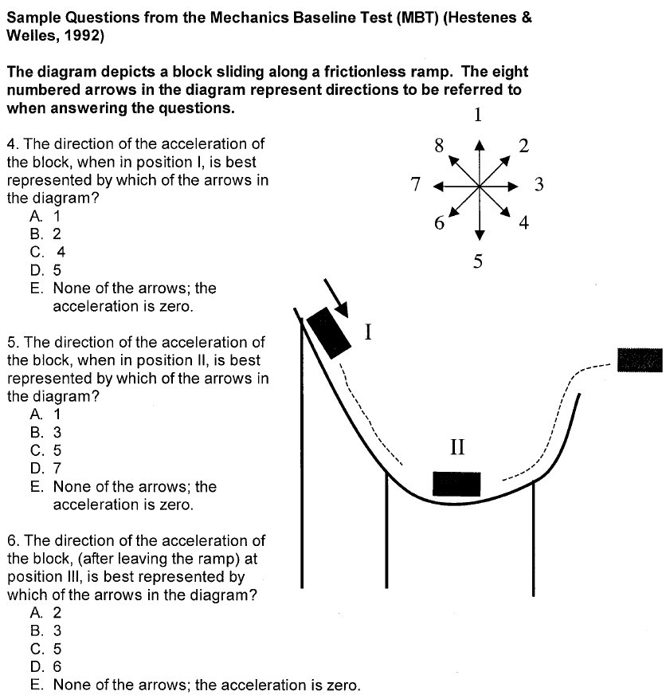

Method for Reviewing / Activating (Prior) Knowledge (2): Concept Map
To structure a concept map exercise for students, follow these three steps:
- Create a focus question that clearly specifies the issue that the concept map should address, such as “What are the potential effects of cap-and-trade policies?” or “What is materials science?”
- Tell students (individually or in groups) to begin by generating a list of relevant concepts and organizing them before constructing a preliminary map.
- Give students the opportunity to revise. Concept maps evolve as they become more detailed and may require rethinking and reconfiguring.
- Create a fill-in-the-blank concept map in which some circles are blank or some lines are unlabelled. Give the map to students to complete (See opposite)
Encourage students to create maps that:
- Employ a hierarchical structure that distinguishes concepts and facts at different levels of specificity
- Draw multiple connections, or cross-links, that illustrate how ideas in different domains are related
- Include specific examples of events and objects that clarify the meaning of a given concept

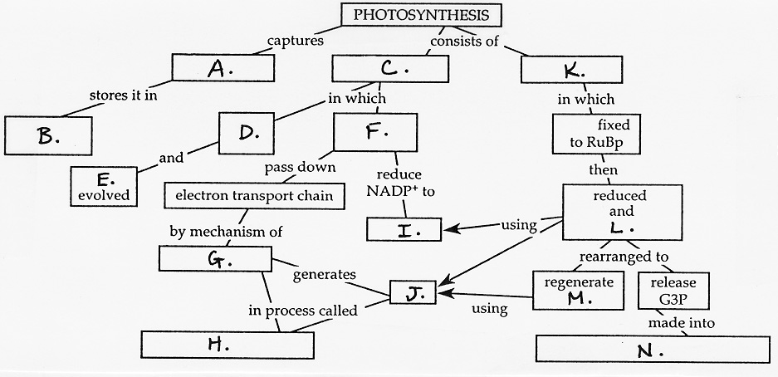

Method for Activating Prior Knowledge (3): Quick Familiarity Check (Self-assessment)

Writing appropriate questions for prior knowledge self-assessments can seem daunting at first. Identifying specific terms, concepts, or applications of skills to ask about will help you write effective questions.
Examples of questions with possible closed responses:
How familiar are you with "Karnaugh maps"?
- I have never heard of them or I have heard of them but don't know what they are.
- I have some idea what they are, but don't know when or how to use them.
- I have a clear idea what they are, but haven't used them.
- I can explain what they are and what they do, and I have used them.
Have you designed or built a digital logic circuit?
- I have neither designed nor built one.
- I have designed one, but not built one.
- I have built one, but not designed one.
- I have both designed and built one.
How familiar are you with a "t-test"?
- I have never heard of it.
- I have heard of it, but don't know what it is.
- I have some idea of what it is, but it’s not very clear.
- I know what it is and could explain what it's used for.
- I know what it is and when to use it, and I could use it to analyse data.

For each of the following Shakespearean plays, place a check mark in the cell if it describes your experience.

Play | Have read it | Have seen a live performance | Have seen a TV or movie production | Have written a college-level paper on it
Hamlet
King Lear
Henry IV
Othello

Method for Reviewing / Activating (Prior) Knowledge (4): Quick Inventory
- Make a list of 10-15 statements related to course content, including commonly held misconceptions.
- Have students mark "true" or "false" next to each statement.

Method for Activating Prior Knowledge (5): Comparative organiser
